**Manage Subscription**

**‘List of all Subscriptions’ Page** – This page shows you a detailed list of registered user subscription. Here, you will see the user, pet name, product name and vet name. You also have the option to edit or delete user subscription information, see subscription details and enter new subscription of the user.

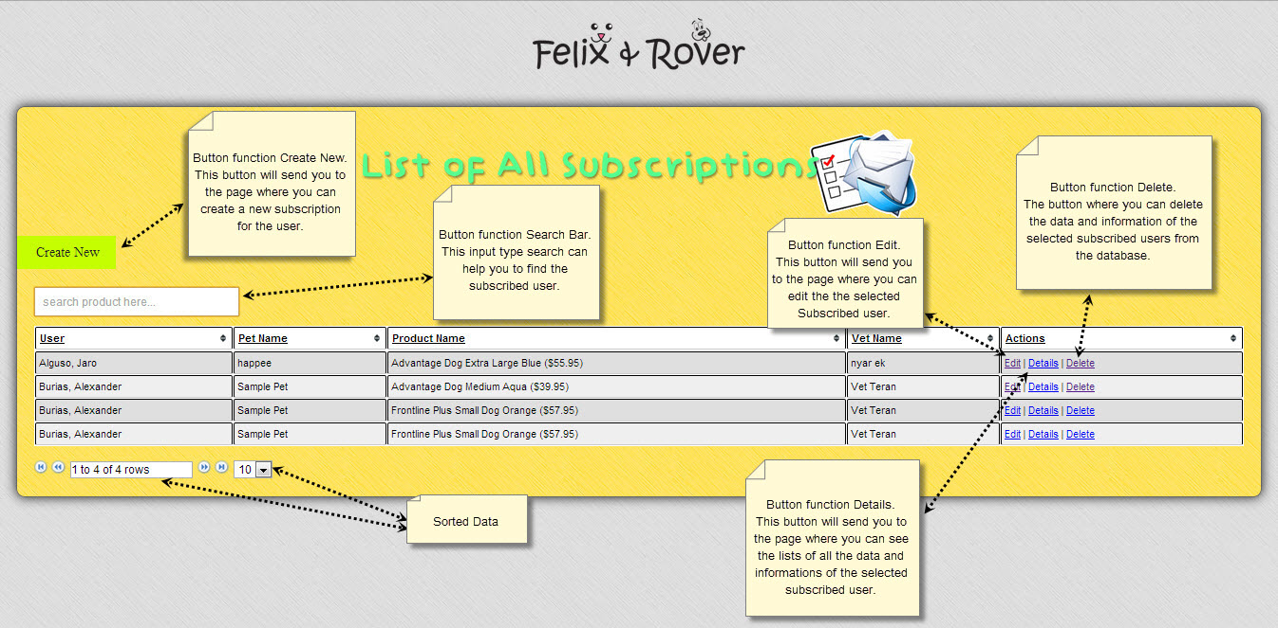

**‘Create New Subscription’ Page** – This page is where you enter type of your new user subscription and also the details of the selected subscribe user.

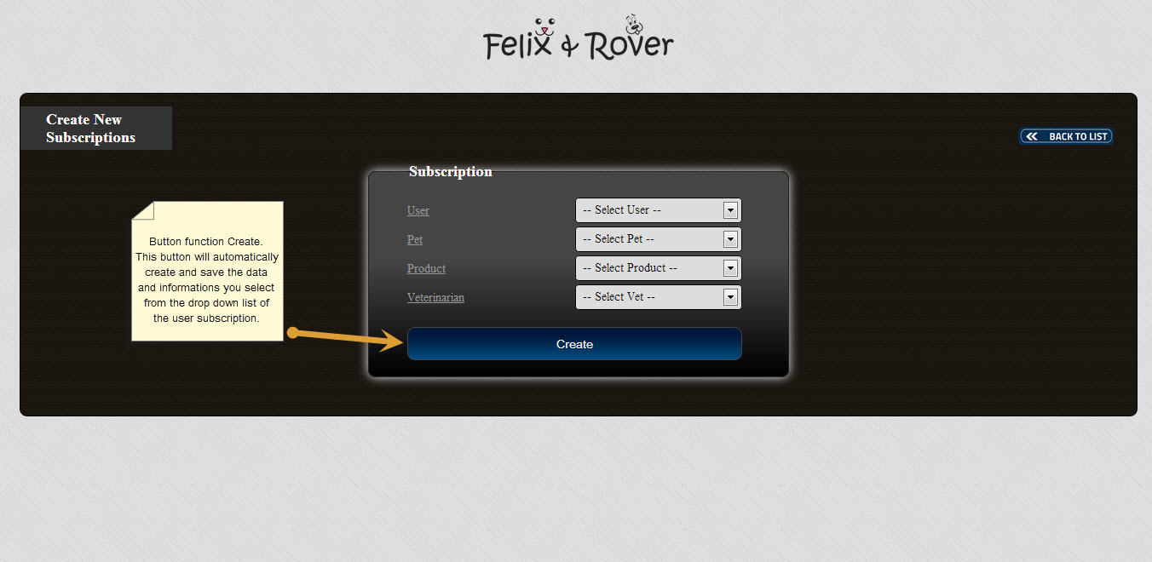

**‘Delete subscription’ Page-** This page is where you go to if you wish to delete subscribed user.

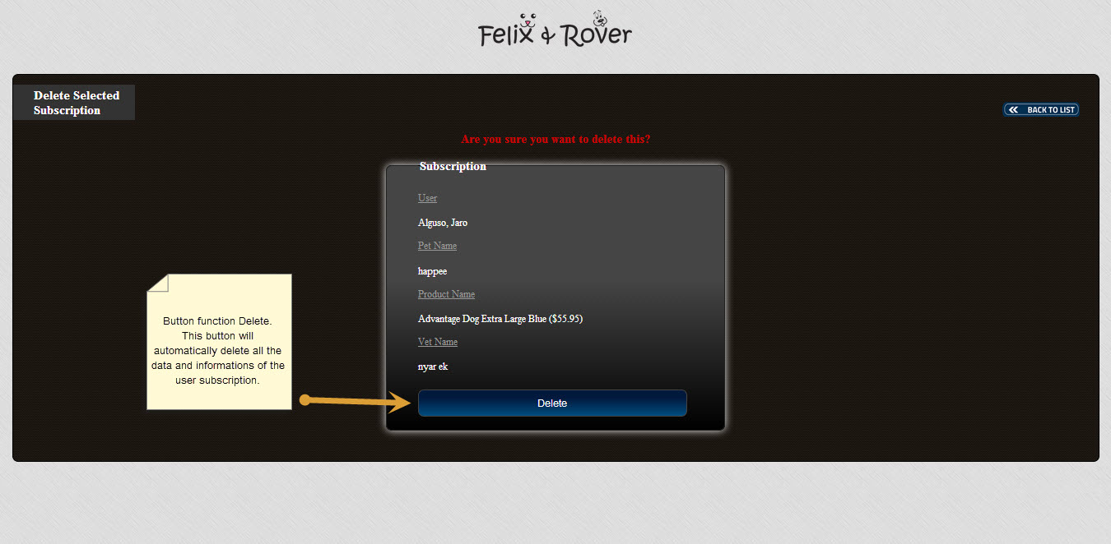

**‘Details of Subscription’ Page** – This page allows you to edit details of subscription users, such as its user, pet name, product name and vet name.

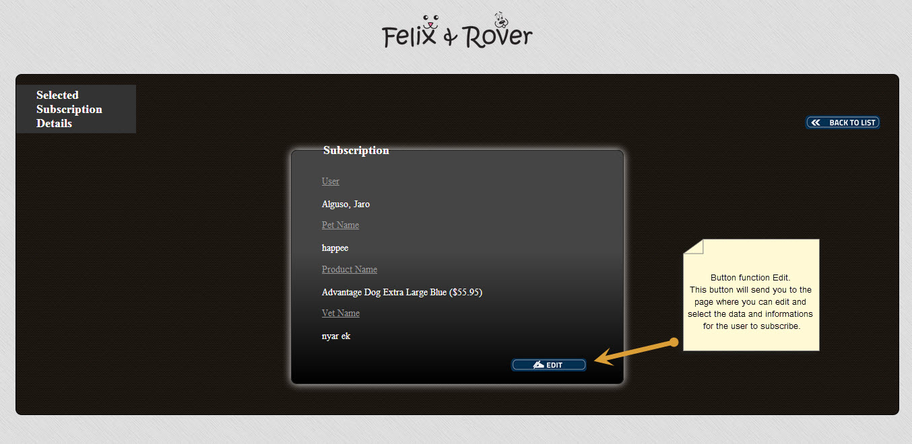

**‘Update Selected Subscription’ Page** – This page is where you can update subscription details if you wish to make changes to its user, pet, product and vet.

